AGENDA

Meeting | London Assembly  (Mayor's Question Time)
Date | Wednesday 21 January 2015
Time | 10.00 am
Place | Chamber, City Hall, The Queen's Walk, London, SE1 2AA

Copies of the reports and any attachments may be found at
www.london.gov.uk/mayor-assembly/london-assembly/whole-assembly

Most meetings of the London Assembly and its Committees are webcast live at www.london.gov.uk/mayor-assembly/london-assembly/webcasts where you can also view past meetings.

A meeting of the Assembly will be held to deal with the business listed below.

Roger Evans AM  Chairman of the London Assembly | Jennette Arnold OBE AM  Deputy Chair
 | Tuesday 13 January 2015

Further Information
If you have questions, would like further information about the meeting or require special facilities please contact: Rebecca Arnold, Committee Services Manager, Tel: 020 7983 4421; Email: rebecca.arnold@london.gov.uk; Minicom: 020 7983 4458.

For media enquiries please contact: Alison Bell; Telephone: 020 7983 5769;
Email: alison.bell@london.gov.uk; Minicom: 020 7983 4458. If you have any questions about individual items please contact the author whose details are at the end of the report.

This meeting will be open to the public, except for where exempt information is being discussed as noted on the agenda. A guide for the press and public on attending and reporting meetings of local government bodies, including the use of film, photography, social media and other means is available at www.london.gov.uk/sites/default/files/Openness-in-Meetings.pdf.

There is access for disabled people, and induction loops are available. There is limited underground parking for orange and blue badge holders, which will be allocated on a first-come first-served basis. Please contact Facilities Management on 020 7983 4750 in advance if you require a parking space or further information.

Proper Officer: Mark Roberts, Executive Director of Secretariat.
If you, or someone you know, needs a copy of the agenda, minutes or reports in large print or Braille, audio, or in another language, then please call us on 020 7983 4100 or email assembly.translations@london.gov.uk.

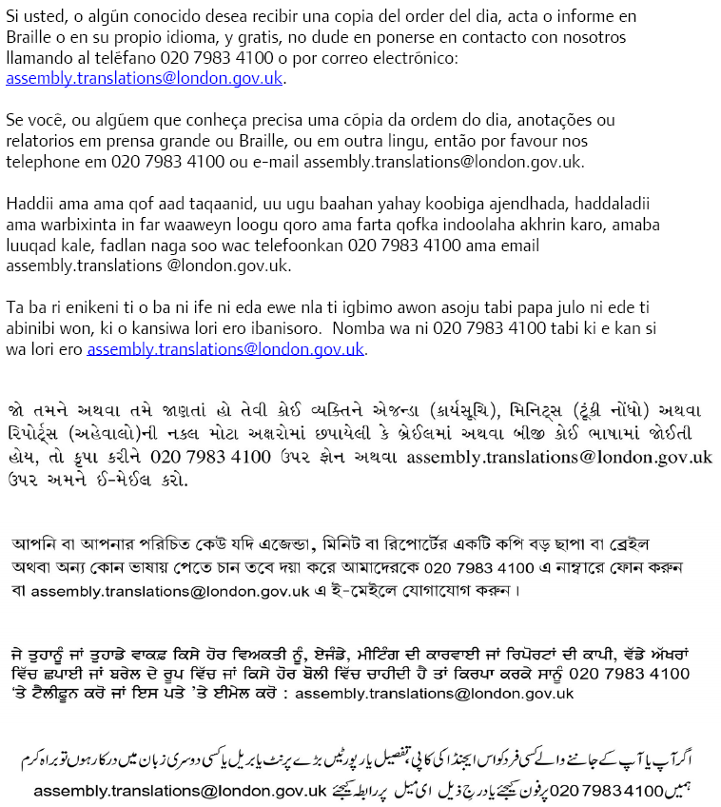

Agenda
London Assembly (Mayor's Question Time)
Wednesday 21 January 2015

- Apologies for Absence and Chairman's Announcements

To receive any apologies for absence and any announcements from the Chairman.

- Declarations of Interests (Pages 1 - 4)

The Assembly is recommended to:

(a) Note the list of offices held by Assembly Members, as set out in the table at Agenda Item 2, as disclosable pecuniary interests;

(b) Note the declaration by any Member(s) of any disclosable pecuniary interests in specific items listed on the agenda and the necessary action taken by the Member(s) regarding withdrawal following such declaration(s); and

(c) Note the declaration by any Member(s) of any other interests deemed to be relevant (including any interests arising from gifts and hospitality received which are not at the time of the meeting reflected on the Authority’s register of gifts and hospitality, and noting also the advice from the GLA’s Monitoring Officer set out at Agenda Item 2) and to note any necessary action taken by the Member(s) following such declaration(s).

- Minutes (Pages 5 - 32)

The Assembly is recommended to confirm the minutes of the London Assembly meetings held on 9 December 2014 (Plenary) and 17 December 2014 (Mayor’s Question Time and Extraordinary Plenary) to be signed by the Chair as a correct record.

The appendices to the minutes of the 9 December and 17 December meetings (including the transcript of the question and answer session held at those meetings) have been circulated to Assembly Members separately. Transcripts and written answers for past meetings can be downloaded from http://www.london.gov.uk/mayor-assembly/london-assembly/whole-assembly

- Mayor's Report (Pages 33 - 66)

The Assembly is recommended to note the Mayor’s Report covering the period from 4 December 2014 to 7 January 2015.

A list of all the decisions taken during the same period is attached, for Members only, on pages 55 to 66, as a background complementary paper to the Mayor’s Report (and as previously published). This document can also be downloaded at: http://www.london.gov.uk/mayor-assembly/london-assembly/whole-assembly

- Questions to the Mayor

(To be circulated separately)

Part A:
The Assembly will put questions to the Mayor.

Part B:
Motion submitted in the name of the Chair:

“That the Assembly notes the answers to the questions asked.”

(The list of questions to be put to the Mayor can also be downloaded at: http://www.london.gov.uk/mayor-assembly/london-assembly/whole-assembly)

- Future Meetings of the London Assembly

London Assembly (Plenary) Meeting – February 2015

It is anticipated that the London Assembly will formally receive the draft further alterations to the London Plan to the Assembly at the end of the January 2015. In accordance with the provisions of Section 42 of the Greater London Authority Act 1999 (as amended), the Assembly has the power to consider and potentially reject draft strategies within 21 days of their publication. The Assembly is asked to agree to delegate authority to the Chairman of the Assembly, in consultation with the Deputy Chair and Assembly Group Leaders, to reschedule the existing February London Assembly (Plenary) meeting – which is currently scheduled to take place at 10am on 11 February 2015 – if/as necessary to an appropriate time and date so that that meeting may be used formally to consider and debate the draft further alterations to the London Plan, once received, and to agree the arrangements for any rescheduled meeting.

The Assembly is recommended to agree to delegate authority to the Chairman of the Assembly, in consultation with the Deputy Chair and Assembly Group Leaders, to reschedule the existing February London Assembly (Plenary) meeting – which is currently scheduled to take place at 10am on 11 February 2015 – if/as necessary to an appropriate time and date so that that meeting may be used formally to consider and debate the draft further alterations to the London Plan, once received, and to agree the arrangements for any rescheduled meeting.

London Assembly (Mayor’s Question Time) Meeting – 23 February 2015

The Mayor’s Question Time meeting which will take place at 10.00am on Monday 23 February 2015 will be used principally to discuss and consider the Final Draft Consolidated Budget for the GLA Group 2015/16.

As in previous years, the Assembly is asked formally to agree to accept written answers to all questions submitted to the 23 February meeting under the Mayor’s Question Time procedure, in order to devote time to discussion of the Mayor’s Final Draft Consolidated Budget 2015/16. The written answers will be provided in the usual way by Thursday 26 February 2015.

The Assembly is recommended to agree to accept written answers to all questions submitted to the 23 January 2015 meeting under the Mayor’s Question Time procedure, in order to devote time to discussion of the Mayor’s Final Draft Consolidated Budget 2015/16.

London Assembly (Plenary) Meeting – 11 March 2015

It is proposed that the Assembly formally agrees to use the 11 March 2015 Plenary meeting principally to hold a question and answer session with the Chairman and Chief Executive of the London Legacy Development Corporation (LLDC).

The Assembly is recommended, under section 61 of the Greater London Authority Act 1999 (as amended), to require the attendance of Boris Johnson, in his capacity as Chairman of the London Legacy Development Corporation, and David Goldstone, Chief Executive, London Legacy Development Corporation, at the 11 March 2015 London Assembly (Plenary) meeting, for which notice will be given in accordance with section 62 of the Greater London Authority Act 1999 in due course, to answer questions in relation to the policies and work of the London Legacy Development Corporation.

- Date of Next Meeting

The next scheduled meeting of the London Assembly will be the Plenary meeting which will take place at 10.00am on Wednesday 28 January 2015 in the Chamber, City Hall.

This meeting will be principally be used to questions to the Mayor on and formally debate the Draft Consolidated Budget for the GLA Group for 2015/16.

- Any Other Business the Chair Considers Urgent

